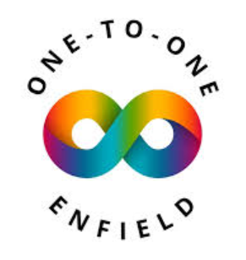
Autism Hub Events – March 2026
Drop-in sessions are open to all members of the public and do not need to be booked. You may have to wait your turn to be seen. Any member can drop in to discuss anything on their mind with a Peer Support Worker and/or an Activity Lead. Housing, referrals, support within the community, including information about One to One Enfield.
Peer Support Groups are a closed group, and therefore, if you would like to join one, you must contact fiona@one-to-one-enfield.co.uk to discuss which group may be right for you. It is important that we keep the groups informed on any changes, including new members.

Wednesday 4th March – Art Group for Autistic Adults
11:30-13:00
St Aldhelms, 2 Windmill Road, London N18 1PA

Wednesday 11th March – Art Group for Autistic Adults
11:30-13:00
St Aldhelms, 2 Windmill Road, London N18 1PA

Wednesday 18th March – Art Group for Autistic Adults
11:30pm-13:00pm
St Aldhelms, 2 Windmill Road, London N18 1PA

Wednesday 25th March – Art Group for Autistic Adults
11:30pm-13:00pm
St Aldhelms, 2 Windmill Road, London N18 1PA

Thursday 26th February – Inclusive Chat and Relax
11:00-12:00
The Ridgeway Tavern, 76 The Ridgeway, EN2 8JF

Thursday 26th March– Online Peer Support Group
19:30-21:00
Microsoft Teams (please email desire@one-to-one-enfield.co.uk for link)

Monday 30th March – Evening Peer Support Group
18:30-20:00
Blake Court – (INVITATION ONLY)

ANY QUESTIONS – CONTACT fiona@one-to-one-enfield.co.uk or or call 0203 971 3984 Mon-Thu 9:30am-2:30pm

